**Manipal University Jaipur**

**TAPMI School of Business and Department of Data Science and Engineering**

**In collaboration with E-Cell**

**With Support From**

**Data Science Society, Sofia, Bulgaria**

**MARKETSIGHTS: UNVEILING DATA INSIGHTS**

|  |  |  |
| --- | --- | --- |
|  |  |  |
|  |  |  |

**A Project Report**

*on*

**Covid 19 Impacts Analysis**

*carried out as part of the datathon Submitted*

by

**Naman Rawal**

**2430020006**

Under the Guidance of

**Guide Name**

**ABSTRACT**

The COVID-19 pandemic has significantly impacted global public health and the economy. This report examines the spread of COVID-19 and its consequences, focusing on health outcomes and economic downturns. The pandemic led to widespread lockdowns, unemployment, and an economic slowdown, affecting both developed and developing nations. In response, governments implemented varying levels of restrictions to curb the spread of the virus.

Methodologically, this report uses data visualization techniques such as line charts, scatter plots, filled maps, bar charts, and bubble charts. These visuals help to analyze trends, correlations, and economic factors like GDP per capita. Critical insights demonstrate that stricter government interventions generally resulted in lower case growth but also contributed to economic challenges. Countries with lower GDP per capita were disproportionately affected, emphasizing the need for stronger healthcare systems and economic recovery strategies. The findings of this analysis provide a foundation for policy recommendations aimed at mitigating the impact of future health crises.

**LIST OF FIGURES**

|  |  |  |
| --- | --- | --- |
| **Figure No** | **Figure Title** | **Page No** |
|  |  |  |
| 1 | Power BI Dashboard Created : Covid-19 Global Insights: Trends, Responses, and Disparities | 8 |
| 2 | Global Trend Over Time | 9 |
| 3 | Evaluating Index vs. Total Cases | 9 |
| 4 | Geographical Distribution of COVID-19 Deaths | 10 |
| 5 | Countries most effected by COVID-19 Death | 10 |
| 6 | Economic Disparity: GDP per Capita and COVID-19 Death Toll | 11 |

**TABLE OF CONTENTS**

1. **Introduction**  
   1.1. Introduction  
   1.2. Problem Statement  
   1.3. Objectives  
   1.4. Scope of Project
2. **Background Detail**  
   2.1. Conceptual Overview  
   2.2. Literature Review
3. **System Design & Methodology**  
   3.1. System Architecture  
   3.2. Development Environment  
   3.3. Methodology
4. **Implementation and Results**  
   4.1. Modules/Classes of Project  
   4.2. Implementation Detail  
   4.3. Results and Discussion  
   4.4. Timeline Chart
5. **Conclusion and Future Plan**

**1. INTRODUCTION**

1.1 **Introduction**  
The COVID-19 pandemic triggered a global health and economic crisis, leading to millions of deaths and economic disruptions. As nations grappled with surging cases, healthcare systems were overwhelmed, and industries halted. Governments imposed restrictions to reduce the spread, leading to mass unemployment, supply chain disruptions, and business closures. Understanding the dynamics of the pandemic and its economic repercussions is critical for formulating long-term recovery plans.

This report presents an in-depth analysis of COVID-19 case growth and its effects on different economies. By leveraging data visualization, we aim to provide insights into how the pandemic unfolded across regions and the economic consequences tied to healthcare outcomes.

1.2 **Problem Statement**  
The sudden spread of COVID-19 caught the world unprepared, leading to both healthcare and economic crises. The need for a comprehensive understanding of the pandemic's effects, including global case distribution, government responses, and economic impacts, is crucial for recovery and preparedness for future pandemics.

1.3 **Objectives**

* Analyze COVID-19 case and death trends globally.
* Investigate the relationship between government intervention (stringency index) and case growth.
* Compare the economic impacts of the pandemic, focusing on unemployment, GDP per capita, and healthcare systems.
* Provide data-driven insights to support future crisis preparedness and recovery strategies.

1.4 **Scope of Project**  
The scope of this project includes the analysis of global COVID-19 data, focusing on public health outcomes and economic implications. The study spans different countries, examining correlations between governmental interventions, case growth, and economic indicators. Data visualizations are employed to interpret and present these insights comprehensively.

**2. BACKGROUND DETAIL**

2.1 **Conceptual Overview**  
COVID-19, caused by the SARS-CoV-2 virus, emerged as a global threat in early 2020. The pandemic spread rapidly, leading to over 200 million confirmed cases and millions of deaths. Lockdowns, social distancing, and travel restrictions were common measures adopted by governments to contain the virus.

The economic impact was equally profound, with unemployment rates skyrocketing and economies shrinking as entire industries were shuttered. This report focuses on analyzing how these interventions, along with healthcare challenges, affected economic stability across different regions.

2.2 **Literature Review**  
Several studies have highlighted the impact of pandemics on global economies. Past outbreaks like SARS and MERS demonstrated how public health crises lead to economic losses, especially in tourism, hospitality, and retail sectors. However, the scale of the COVID-19 pandemic surpassed previous events, causing widespread unemployment, poverty, and healthcare expenditures. Recent literature emphasizes the need for better healthcare infrastructure and economic resilience to cope with such crises.

**3. SYSTEM DESIGN & METHODOLOGY**

3.1 **System Architecture**  
This project follows a structured approach to data analysis. The key steps include data collection, preprocessing, and the application of various visualization techniques. The architecture for this project includes a pipeline for ingesting data, transforming it into useful formats, and generating visual representations of the data to aid in analysis.

* **Data Collection**: Dataset provided for analysis.
* **Data Transformation**: Cleaning and structuring data into a usable format for analysis.
* **Data Visualization**: Representing data using line charts, scatter plots, maps, bar charts, and bubble charts.

3.2 **Development Environment**

* **Hardware**: The project was executed on a standard computing environment with 8GB RAM.
* **Software**: MS-Excel was used for data processing. For interactive visualizations, Power BI was utilized.

3.3 **Methodology**  
Data were grouped by date and region, followed by summing total cases and deaths for each country. Visualizations were produced based on this aggregated data, with specific methods as follows:

* **Line Chart**: Used to depict global trends in COVID-19 cases and deaths.
* **Scatter Plot**: Displayed the correlation between the stringency index and total cases.
* **Filled Map**: Illustrated the geographic distribution of cases.
* **Bar Chart**: Showed the top 10 countries with the highest COVID-19 cases and deaths.
* **Bubble Chart**: Visualized the relationship between GDP per capita and the death rate, using bubbles sized by population.

**4. IMPLEMENTATION AND RESULTS**

4.1 **Modules/Classes of Project**  
The project was divided into the following modules:

* **Data Preprocessing**: Cleaning and preparing the data for analysis.
* **Visualization**: Generating charts to illustrate key insights.
* **Analysis**: Interpreting the visualizations to understand the relationships between variables like government response, case growth, and economic impact.

4.2 **Implementation Detail**

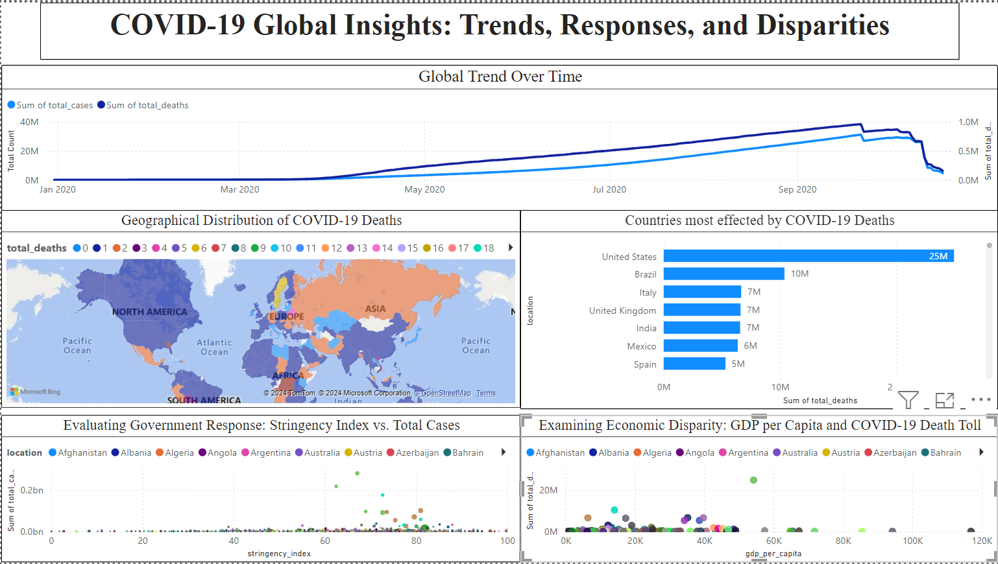

Fig 1. Power BI Dashboard Created : Covid-19 Global Insights: Trends, Responses, and Disparities

**1. Global COVID-19 Trends (Line Chart)**

* **Result**: The chart showed clear spikes in case numbers corresponding to different waves of the pandemic. The highest spike in deaths occurred shortly after each major rise in cases, indicating the delay between case detection and fatalities.
* **Key Insight**: This visualization allowed for identifying critical periods when healthcare systems were overwhelmed, which correlated with increased unemployment and lockdown policies. It also highlighted how, despite ongoing vaccinations and treatments, subsequent waves still had a substantial impact.

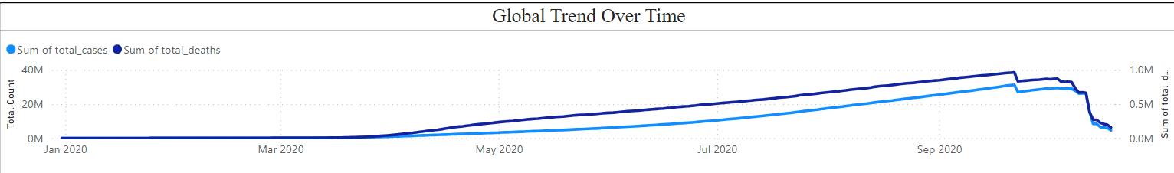

Fig 2. Global Trend Over Time

**2. Stringency Index vs. Total Cases (Scatter Plot)**

* **Data Handling**: The stringency index data was plotted against total COVID-19 cases for multiple countries. Each point represented a country, with the horizontal axis showing the stringency index and the vertical axis showing total cases.
* **Result**: A trend emerged where countries with higher stringency measures (e.g., stringent lockdowns, travel bans) generally had fewer total cases. Outliers were identified, where despite stringent measures, some countries still experienced high case counts.
* **Key Insight**: While stricter government measures often corresponded to lower case growth, the outliers suggested that factors such as healthcare system quality, public compliance, and virus variants played significant roles in controlling the pandemic. The scatter plot also visually demonstrated the economic trade-offs, as stricter measures often led to increased unemployment and economic downturns.

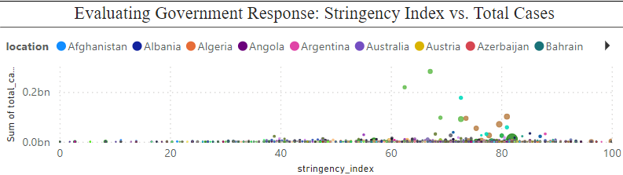

Fig 3. Evaluating Index vs. Total Cases

**3. Total COVID-19 Cases by Country (Filled Map)**

* **Data Handling**: The total COVID-19 case data was mapped onto a filled map (choropleth), where countries were shaded based on the number of cases.
* **Result**: The filled map highlighted global hotspots, with countries like the United States, India, and Brazil standing out for having high case counts. In contrast, several countries in Africa had relatively fewer cases, though their healthcare systems were severely impacted by even small outbreaks.
* **Key Insight**: This visualization provided an immediate geographical understanding of where the pandemic hit hardest. Regions with large populations and highly urbanized areas showed significantly higher case counts. This led to severe economic strain, especially in tourism-dependent economies and countries with limited healthcare infrastructure.

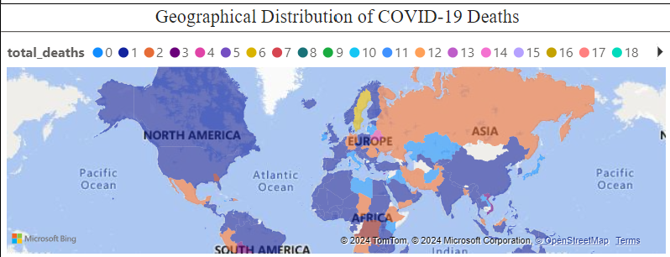

Fig 4. Geographical Distribution of COVID-19 Deaths

**4. Top 10 Countries by COVID-19 Cases and Deaths (Bar Chart)**

* **Data Handling**: The top 10 countries by total cases and deaths were aggregated and displayed using a bar chart. Both cases and deaths were shown to highlight the relationship between case numbers and mortality.
* **Result**: The United States, India, and Brazil appeared at the top of both the case and death charts. However, countries like Mexico and Russia also showed disproportionately high deaths relative to their case counts, suggesting potential healthcare system inadequacies or underreporting.
* **Key Insight**: This bar chart emphasized the disparity in outcomes across nations. Countries with robust healthcare systems (like Germany) fared better despite high case numbers, while countries with fragile healthcare infrastructures struggled with high mortality rates. This visualization was crucial in understanding the relationship between economic investment in healthcare and pandemic outcomes.

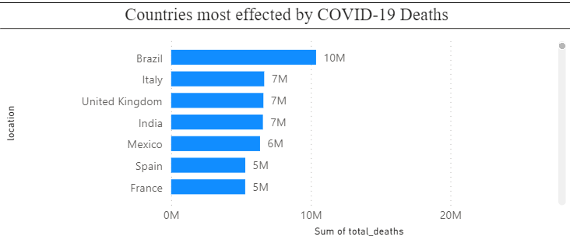

Fig 5. Countries most effected by COVID-19 Death

**5. GDP per Capita vs. COVID-19 Death Rate (Bubble Chart)**

* **Data Handling**: GDP per capita was plotted against the death rate (total deaths/population), with bubble sizes representing the population of each country.
* **Result**: Countries with higher GDP per capita, like those in Western Europe and North America, generally had lower death rates. In contrast, low-income countries with weaker healthcare systems, such as some in Africa and South Asia, showed higher death rates.
* **Key Insight**: This chart visually reinforced the correlation between economic status and pandemic outcomes. Wealthier countries, despite facing high case numbers, were better equipped to mitigate fatalities due to stronger healthcare systems, while lower-income countries faced higher mortality. The size of the bubbles highlighted how population density and size also played roles in the severity of outcomes.

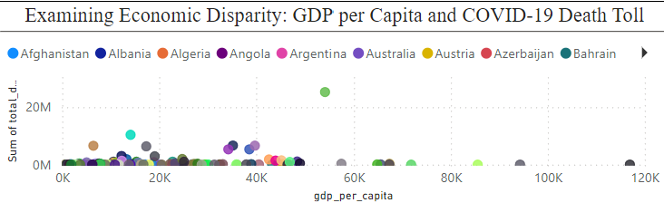

Fig 6. Examining Economic Disparity: GDP per Capita and COVID-19 Death Toll

4.3 **Results and Discussion**

* **Global Trends**: Several spikes in cases aligned with second and third waves of the virus, reflecting the challenges governments faced in maintaining long-term restrictions.
* **Economic Impacts**: The visualizations showed that lower-income countries with weaker healthcare systems suffered greater health consequences. Stringent lockdowns, while necessary to control case growth, resulted in severe economic downturns, highlighting the delicate balance governments had to maintain.

4.4 **Timeline Chart**  
A timeline chart was created to show the progression of global economic shutdowns, recovery efforts, and subsequent waves of COVID-19, offering insights into how different regions managed the crisis over time.

**5. CONCLUSION AND FUTURE PLAN**

This report provides a comprehensive

analysis of the COVID-19 pandemic’s effects on global public health and the economy. Through data visualization, it illustrates the relationship between government interventions, case growth, and economic outcomes.

**Future Plans**:

* Conduct deeper analysis into the recovery trajectories of different economies.
* Analyze the long-term impacts of COVID-19 on unemployment, poverty, and healthcare spending.
* Investigate the effectiveness of vaccination campaigns and their impact on economic recovery.